**Face-Recognition Based Attendance system**

AN INDUSTRIAL INTERNSHIP TRAINING REPORT

*Submitted by*

**P.ILLAVENIL**

**17BEC1046**

**ECE3099 – INDUSTRIAL INTERNSHIP**

*in partial fulfillment for the award of the degree of*

**BACHELOR OF TECHNOLOGY**

in

**ELECTRONICS AND COMMUNICATION ENGINEERING**



OCTOBER 2020

**School of Electronics Engineering**

**DECLARATION BY THE CANDIDATE**

I hereby declare that the Industrial Internship Report entitled “ **Face Recognition based Attendance system”** submitted by me to VIT, Chennai in partial fulfillment of the requirement for the award of the degree of **Bachelor of Technology** in **Electronics and communication Engineering** is a record of bonafide industrial training undertaken by me held at **Paragon Dynamics Info Systems Pvt Ltd.** I further declare that the work reported in this report has not been submitted and will not be submitted, either in part or in full, for the award of any other degree or diploma in this institute or any other institute or university.

Chennai Signature of the Candidate

Date: Register Number:

17bec1046

Student Name:

P.Illavenil



**1. Paragon Dynamics Info Systems Pvt Ltd**

Paragon Dynamics was founded in the year 2007. We are pioneer in providing turnkey Industry Solutions, ERP and Business solutions. At Paragon Dynamics, They work with their clients to develop strategic one-to-one complete solutions in the field of Internet Technology, e-Business, Engineering Solutions, Mobile Solutions, Mobility Solutions, Apps Solutions, Gaming Solution, Healthcare.They have Software Development expertise in Retail, MRM, CRM, Travel, Banking, HR Management, Shipping and Logistics domain .

Paragon is the inventor and creator of multiple products. Paragon has been bridging gaps between Marketing, Communication and ICT. Their products and services result from almost 15 years’ experience in the field of developing and implementing marketing and brand management software.

Their team of more than 100 employees continually work on projects for clients and the further development of MarketingOne. Our clients describe us as sensible, engaged, driven and innovative.

Their Vision and goals is to deliver Solutions in Line with ever changing consumer experience that is tangible and sustainable, and as a trusted partner, their solution drives and guarantees the delivery of the best in class ‘TANGIBLE’ differentiators through laser focus on Quality Solutions

# **CHAPTER 2 ( Paragon Dynamics Info Systems Pvt Ltd)**

**FACE RECOGNTION ATTENDANCE SYSTEM**

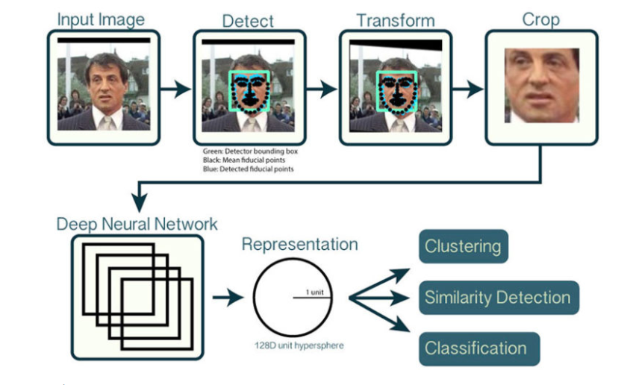

*Fig FaceRecognition pipeline*

# **4.1 Open CV Face detection**

To build our face recognition system, we’ll first perform face detection, extract face embeddings from each face using deep learning, train a face recognition model on the embeddings, and then finally **recognize faces in both images and video streams with OpenCV.**

**We would need to install and import certain python packages before proceeding.**

1. OpenCV
2. TensorFlow
3. Dlib
4. Face_recognition(which is an easy to use set of face recognition utilities that wraps around dlib)
5. Haar cascade ( Face Detection tool)

**4.1.1 Haar cascade**

Object Detection using Haar feature-based cascade classifiers is an effective object detection method proposed by Paul Viola and Michael Jones in their paper, "Rapid Object Detection using a Boosted Cascade of Simple Features" in 2001. It is a machine learning based approach where a cascade function is trained from a lot of positive and negative images. It is then used to detect objects in other images.

Here we will work with face detection. Initially, the algorithm needs a lot of positive images (images of faces) and negative images (images without faces) to train the classifier. Then we need to extract features from it. For this, Haar features shown in the below image are used. They are just like our convolutional kernel. Each feature is a single value obtained by subtracting sum of pixels under the white rectangle from sum of pixels under the black rectangle.

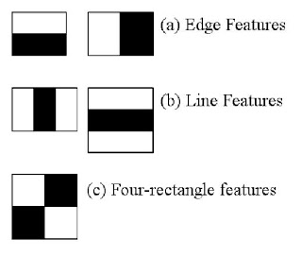

Fig 4.2 feature extraction

Using the cv2.CascadeClassifier.detectMultiScale we detect multiple human faces present in a image or a video frame, and the we use the cv2.rectangle function to draw a box in the region where the face is detected.

After we detect the faces in our image. But now we have to deal with the problem that faces turned different directions look totally different to a computer.

To account for this, we will try to warp each picture so that the eyes and lips are always in the sample place in the image. This will make it a lot easier for us to compare faces in the next steps.To do this, we are going to use an algorithm called **face landmark estimation**.

4**.2 Face Encoding & recognition:**

We train a deep neural network to find 128 measurement of any face. This 128 measurement of a face is known as the face_encoding. Machine learning people call the 128 measurements of each face an embedding. The idea of reducing complicated raw data like a picture into a list of computer-generated numbers comes up a lot in machine learning.

Each face is given a name is the data base and each and every different faces have different face encoding .When our pre-trained model is asked to predict the new face it measures the similarity of the new face with those in our data base. If two images and their face embeddings are same our model recognizes the person and name of the person is printed on top the rectangle box. If the new face matches no faces in our database the model prints unknown face.

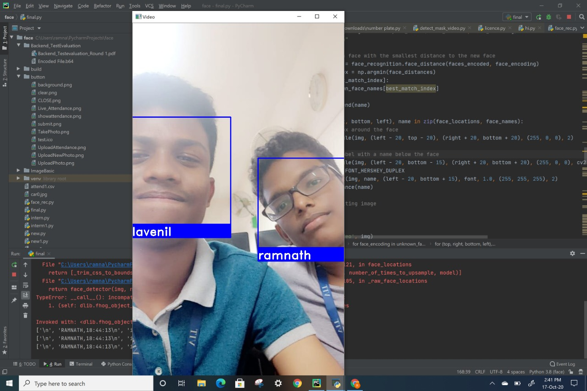

*fig 4.3 face recognition*

**4.3Attendance:**

We define a function called mark attendance. We first open a csv file and read the lines in the csv file to check for duplicates . As soon as a face is recognized by the web cam the name gets updated in the csv file along with time of entry If the student name already exist in csv then it will not be repeated.

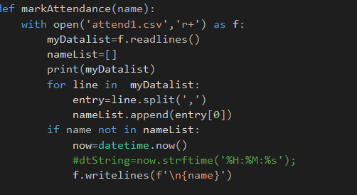

Fig Attendance function

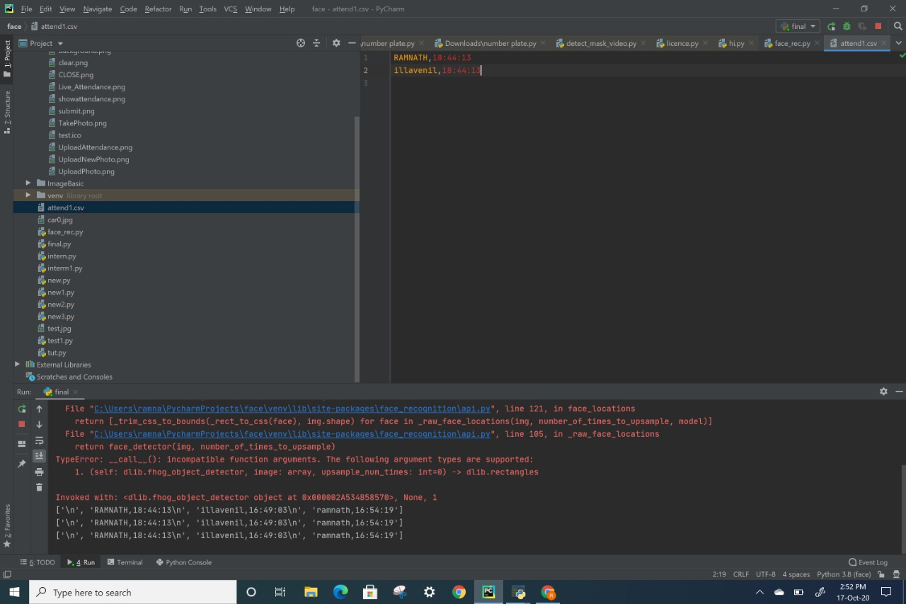

**Fig Attend.csv**

**4.4 User Interface:**

We used Python Tkinter tool to build the user Interface.

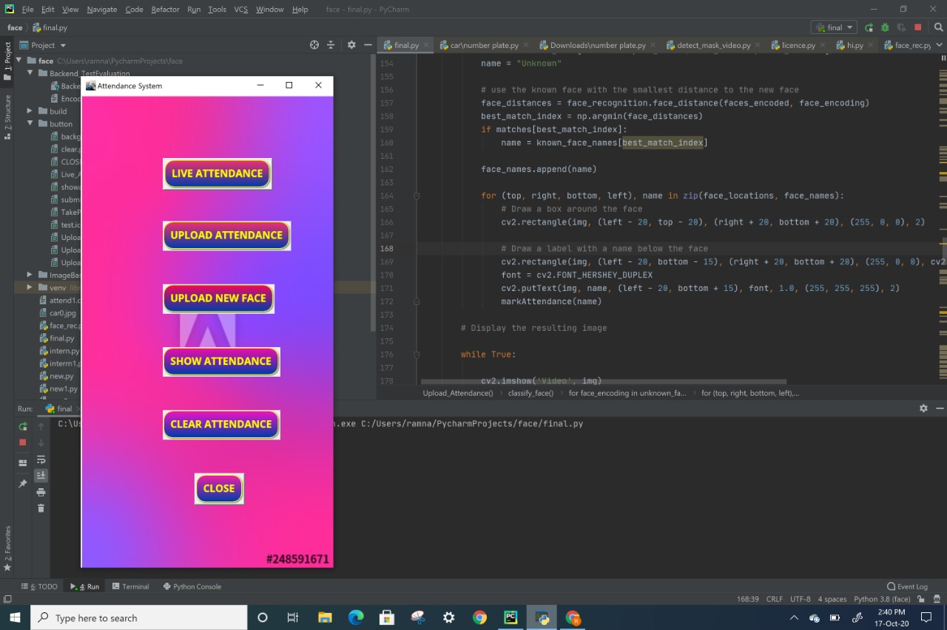

Fig Tkinter interfacce

On Clicking the Live attendance the camera shoots open and on clicking upload attendance we can upload a image of all students present in class and the CSV file will pop up with all recognized faces.

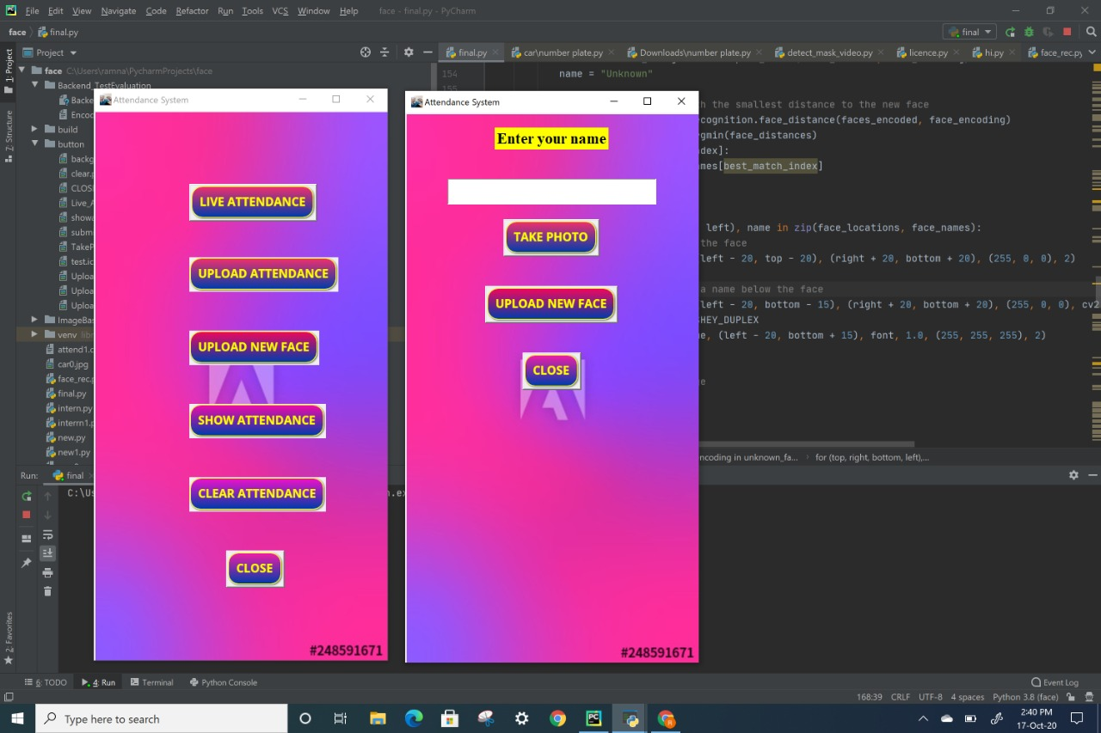

*Fig UI 2*

On clicking upload new face a new interface will pop up and the faculty member can upload face or take picture of a new student and add it to the data base . Show attendance will open the csv file and clear attendance as name mentions will erase the csv file.